

**Dr. D. Y. Patil Unitech Society’s**

**Dr. D. Y. Patil Arts, Commerce and Science College, Pimpri, Pune-18**

A PROJECT REPORT ON

## “Version Control System”

**Developed by**

**Prajwal Narayan Bagewadi**

**In partial fulfillment of**

**T.Y.B.C.A ( Science) Sem-VI**

**Under**

**Savitribai Phule Pune University 2024-2025**



**Dr. D. Y. Patil Unitech Society’s**

**Dr. D. Y. Patil Arts, Commerce and Science College, Pimpri, Pune-18**

**CERTIFICATE**

Exam Seat No.:___748___

This is to certify that **Name: Prajwal Narayan Bagewadi (roll no:04)** has successfully completed the Project Work entitled **____________________________________________**

for **T.Y.B.C.A(Science) Sem-VI** of Savitribai Phule Pune University for the Academic Year 2024-25.

**Project Guide Coordinator I/C Principal & H.O.D. (C.S)**

**External Examiner Internal Examiner**

**Acknowledgement**

I would like to express my sincere gratitude to all those who have contributed to the successful completion of this project. It has been my sincere effort to present the subject in a simple and clear manner, and I am truly appreciative of the guidance and support provided by everyone involved.

First and foremost, I would like to extend my heartfelt thanks to my project guide, Mrs. Neeta Takawale, for their valuable guidance and constant support throughout the project. Their insights and expertise have been instrumental in the development of this work.

I am also deeply grateful to Dr. Ranjit Patil, Principal of the College, for their unwavering support and encouragement. Special thanks to Dr. Sujata Patil, Coordinator of the Department, for her continuous assistance and guidance.

Working on this project has been an incredibly enriching and enlightening experience. I have learned that "team spirit makes even the most difficult tasks easier and more enjoyable." I would like to thank my friends for their cooperation, keen interest, and valuable suggestions that contributed to the success of this project.

Once again, my heartfelt thanks to everyone who supported me in this endeavor.

INDEX

|  |  |
| --- | --- |
| SR. No. | Content |
| 1 | Introduction to System |
| 2 | System Analysis   * 1. Existing System   2. Need of Computerization   3. Proposed System   4. Scope and Objective of Proposed System   5. Fact Finding Techniques   6. Feasibility Study |
| 3 | Requirement Specification |
| 4 | System Design   * 1. Entity Relationship Diagram   2. Data Flow Diagram   3. Class Diagram   4.4. Use case Diagram   * 1. Activity Diagram   2. Sequence Diagram   3. Deployment diagram   4. Data Dictionary |
| 5 | System Implementation |
| 6 | Input-Output Screen & Reports |
| 7 | Limitations |
| 8 | Future Enhancements |
| 9 | Conclusion |
| 10 | References |

1. **INTRODUCTION**

In the rapidly evolving landscape of software development, mastering efficient version control is paramount for fostering seamless collaboration, ensuring high code quality, and driving project success.

While platforms like GitHub have transformed the way teams manage their code, numerous challenges remain—ranging from ineffective issue management and the struggle to navigate expansive repositories, to the daunting complexities of code review fatigue.

This project aspires to create a groundbreaking version control system that not only enhances workflow efficiency but also revolutionizes collaboration and elevates code management practices. By tackling fundamental pain points such as inadequate issue tracking, repository intricacies, and cumbersome code reviews, our system will unveil innovative solutions—featuring structured issue management, state-of-the-art repository navigation tools, and streamlined pull request workflows.

With these enhancements, our system will empower development teams with a more intuitive, organized, and productive version control experience, ultimately leading to superior code quality and transformative project outcomes.

# SYSTEM ANALYSIS

System analysis plays a pivotal role in shaping the future of next-generation version control systems. This essential phase not only uncovers existing challenges but also delves deep into understanding user needs. By crafting innovative and effective solutions, we can significantly enhance workflow efficiency, foster collaboration, and elevate code management to new heights.

## 2.1 EXISTING SYSTEM

The current version control system, while effective in managing source code, presents several challenges that hinder development workflow, collaboration, and code quality.

Below are the key issues observed in the existing system

**1. Poor Issue Management Practices**

* **Unclear Issue Descriptions**: Many issues lack proper context, making it difficult for developers to understand and resolve them efficiently.
* **Lack of Proper Labelling**: Without well-defined labels, categorizing and prioritizing issues becomes challenging.
* **Inefficient Tracking & Resolution**: The absence of structured workflows results in issues being overlooked or addressed late.

**Impact:**

* + Developers spend excessive time understanding and categorizing issues.
  + Delays in resolving critical bugs and feature requests.
  + Poor communication between contributors and maintainers.

**2. Difficulty Navigating Large Repositories**

* **Complex Codebases**: Large repositories with thousands of files make it hard to locate specific code sections.
* **Ineffective Search Mechanisms**: Standard search features lack the ability to filter and locate code efficiently.
* **Lack of Modularization**: Poorly structured repositories make code maintenance and onboarding difficult.

**Impact:**

* Reduced productivity due to prolonged search times.
* Increased chances of redundant code or conflicting implementations.
* Steeper learning curve for new contributors.

**3. Potential for Code Review Fatigue**

* **High Volume of PRs**: Developers struggle to manage and review multiple pull requests.
* **Manual Conflict Resolution**: Handling merge conflicts manually increases workload and slows down progress.
* **Inconsistent Review Standards**: Different reviewers use varying review styles, leading to uneven code quality.
* **Unclear PR Prioritization**: Lack of mechanisms to prioritize critical pull requests results in delays.

**Impact:**

* Reviewers experience burnout, leading to delayed or superficial reviews.
* Inconsistent coding standards across the project.
* Increased risk of introducing undetected bugs into the main codebase.

## 2.2 NEED OF COMPUTERIZATION.

In modern software development, efficient version control is crucial for managing code, collaborating effectively, and ensuring high-quality software delivery. However, traditional methods of handling issues, navigating repositories, and reviewing code manually introduce inefficiencies that hinder productivity. To overcome these challenges, **computerization** of version control systems is essential.

**1. Improved Issue Management**

* **Automation of Issue Tracking** – Ensures that issues are well-documented, categorized, and updated in real time.
* **Standardized Templates & Labels** – Helps in providing clear issue descriptions, making problem resolution faster.
* **Automated Notifications** – Keeps all team members informed about issue updates, reducing communication gaps.

**Why Computerization?**

* Eliminates manual tracking errors.
* Ensures systematic issue handling.
* Enhances team coordination with real-time updates.

**2. Efficient Repository Navigation**

* **Advanced Search Mechanisms** – Helps developers quickly locate specific files, functions, or commits within large codebases.
* **Modular Repository Structure** – Organizes code into structured directories for easier maintenance.
* **Repository Analytics** – Provides insights into frequently accessed files, inactive code sections, and contributions.

**Why Computerization?**

* Reduces time spent searching for files.
* Improves code discoverability and accessibility.
* Simplifies repository maintenance and onboarding for new developers.

## 2.3 PROPOSED SYSTEM

The next-generation version control system aims to overcome the limitations of the existing system by introducing structured issue management, advanced repository navigation, and an optimized code review process. These enhancements will streamline workflows, improve collaboration, and boost overall development efficiency.

**1. Improved Issue Management**

To ensure effective tracking and resolution of issues, the system will introduce the following features:

* **Issue Templates** – Standardized templates for bug reports, feature requests, and tasks to maintain consistency.
* **Labels & Tags** – Categorization of issues based on priority, status, and type to enhance tracking.

**Expected Benefits:**

* Faster issue resolution with clear descriptions and categorization.
* Improved communication and transparency within the development team.
* Reduced time spent managing and tracking issues.

**2. Improved Issue Management**

To ensure effective tracking and resolution of issues, the system will introduce the following features:

* **Issue Templates** – Standardized templates for bug reports, feature requests, and tasks to maintain consistency.
* **Labels & Tags** – Categorization of issues based on priority, status, and type to enhance tracking.
* **Automated Notifications** – Real-time updates to keep all stakeholders informed about issue progress.
* **Smart Issue Prioritization** – AI-assisted ranking of issues based on urgency and impact.

**Expected Benefits:**

* Faster issue resolution with clear descriptions and categorization.
* Improved communication and transparency within the development team.
* Reduced time spent managing and tracking issues.

**3. Efficient Code Review**

To address code review fatigue and inefficiencies, the system will implement:

* **PR Prioritization** – Automated ranking of pull requests based on complexity, urgency, and dependency.
* **Standardized Review Templates** – Predefined templates for code reviews to ensure consistency in feedback.
* **Smart Review Assignment** – Intelligent distribution of PRs based on developer expertise and workload.

**Expected Benefits:**

* Reduced reviewer fatigue by prioritizing and automating tasks.
* Faster and more consistent review cycles.
* Improved code quality and reduced risk of undetected bugs.

## 2.4 SCOPE AND OBJECTIVE OF PROPOSED SYSTEM

### Scope of the Proposed System:

The **next-generation version control system** aims to overcome the limitations of existing platforms by introducing structured issue management, advanced repository navigation, and an optimized code review process. These enhancements will **streamline workflows, improve collaboration, and boost overall development efficiency** for modern software team

### Objectives of the Proposed System:

1. **Enhancing Issue Management**

* Standardizing issue tracking with **templates, labels, and tags**.
* Implementing **real-time notifications** for better collaboration.
* Introducing **AI-based prioritization** of issues based on severity and impact.

1. **Optimizing Repository Navigation**

* Using **modular codebase structures** for better file organization.
* Integrating **advanced search tools** for efficient file discovery.
* Implementing **repository analytics** to track usage patterns and contributions.

1. **Improving the Code Review Process**

* Automating **pull request (PR) prioritization** for efficient review workflows.
* Standardizing **review templates** to maintain feedback consistency.
* Assigning PRs intelligently based on **developer expertise and workload**.

**Expected Impact**

* Faster issue resolution and improved project transparency.
* Increased developer productivity by simplifying code navigation.
* Reduced code review fatigue and enhanced software quality.

## 2.5 FACT FINDING TECHNIQUES

Fact-finding techniques are essential in system analysis and design to gather

accurate requirements, understand user needs, and identify existing system

shortcomings. The following methods were used to collect data for the

development of the **next-generation version control system**.

**1. Interviews**

**Purpose**: To gather insights from developers, project managers, and other

stakeholders regarding the challenges they face in version control.

* Conducted structured and unstructured interviews with team members.
* Identified pain points in issue tracking, repository navigation, and code

review processes.

* Gathered suggestions for potential improvements.

**Outcome**: Clear understanding of existing problems and user expectations.

**2. Questionnaires**

**Purpose**: To collect feedback from a larger audience, including developers, testers, and team leads, about their experiences with current version control systems.

* Distributed online surveys with both **open-ended and multiple-choice questions**.
* Focused on common issues such as **PR management, issue tracking, and repository navigation**.
* Collected quantitative and qualitative data to support findings.

**Outcome**: Statistically backed insights on pain points and areas needing improvement.

**3. Observation**

**Purpose**: To analyse real-time usage of existing version control systems and identify inefficiencies in workflow.

* Observed developers **using GitHub for code management, issue tracking, and PR reviews**.
* Noted bottlenecks such as **manual issue categorization, difficulty in searching files, and lengthy code reviews**.
* Evaluated the impact of these inefficiencies on productivity.

**Outcome**: Identified **workflow inefficiencies** that require automation and enhancement.

**4. Document Analysis**

**Purpose**: To review existing version control policies, guidelines, and best practices.

* Analysed GitHub’s **current issue tracking, pull request management, and repository organization guidelines**.
* Reviewed past **bug reports, feature requests, and PR review logs** to understand common patterns.
* Compared different version control tools (GitHub, GitLab, Bitbucket) to identify gaps and potential improvements.

**Outcome**: Data-driven approach to defining system requirements and enhancements.

**5. Prototyping**

**Purpose**: To create an initial model of the proposed system for early feedback.

* Developed a **basic prototype** demonstrating **automated issue tracking, enhanced repository navigation, and optimized PR workflows**.
* Gathered feedback from testers and refined features based on their input.
* Ensured the system meets the needs of developers before full-scale development.

**Outcome**: Early validation of features and better alignment with user expectations.

## 2.6 FEASIBILITY STUDY

The **feasibility study** assesses the practicality of implementing the proposed next-generation version control system. It evaluates various aspects to determine whether the project is **technically, economically, operationally, legally, and schedule-wise feasible**.

**1. Technical Feasibility**

**Purpose**: To determine whether the system can be developed with the available technology and resources.

* Uses **existing version control technologies** like Git and integrates with platforms like GitHub.
* Implements **AI-powered tools for issue prioritization and automated conflict resolution**.
* Employs **modern search algorithms** for enhanced repository navigation.
* Utilizes **cloud-based solutions** for scalability and accessibility.

**Conclusion**: The required technologies are readily available and can be effectively implemented.

**2. Economic Feasibility (Cost-Benefit Analysis)**

**Purpose**: To analyse whether the project is financially viable by comparing costs and benefits.

* **Development Costs** – Includes system design, programming, and testing.
* **Operational Costs** – Hosting, maintenance, and updates.
* **Training Costs** – Minimal, as it integrates with existing workflows.
* **Expected Benefits** – Increased developer productivity, reduced code review time, and improved issue tracking.

**Cost-Benefit Justification**

* Reduction in development time increases overall efficiency.
* Fewer errors and faster issue resolution save operational costs.
* Improved code quality leads to fewer post-production defects.

**Conclusion**: The long-term benefits **outweigh the initial costs**, making it **economically viable**.

**3. Operational Feasibility**

**Purpose**: To assess whether the system will function effectively within the organization’s workflow.

* Designed to integrate **seamlessly** with GitHub and other version control platforms.
* Improves existing workflows without **requiring major process changes**.
* Increases efficiency in **issue tracking, repository navigation, and code reviews**.
* Reduces reviewer fatigue, making it more **user-friendly and effective**.

**Conclusion**: The system is **highly feasible** in improving software development efficiency.

**4. Legal Feasibility**

**Purpose**: To ensure compliance with software licensing, data privacy, and industry regulations.

* Complies with **open-source licensing** when integrating with Git-based platforms.
* Adheres to **data protection laws** (e.g., GDPR, CCPA) when handling user data.
* Uses **secure authentication and access control mechanisms** to prevent unauthorized access.

**Conclusion**: The system **meets legal and regulatory requirements** and poses no legal risks.

**5. Schedule Feasibility**

**Purpose**: To evaluate whether the system can be developed within the required timeline.

* The system follows an **agile development approach**, ensuring incremental progress.
* Estimated development time: **4-6 months**, including testing and deployment.
* Early-stage **prototyping** ensures faster validation and reduces delays.

**Conclusion**: The project **can be completed on time** with proper resource allocation.

# 3. REQUIREMENT SPECIFICATION

**Hardware and Software Requirements**

This section details the necessary **hardware and software specifications** required for the **next-generation version control system**.

**Hardware Requirements**

**1.1 Server or Cloud Infrastructure**

The system requires a **reliable server or cloud environment** to host repositories, manage databases, and support continuous integration.

**Minimum Server Specifications:**

* **CPU**: Quad-core processor or equivalent.
* **RAM**: 8 GB or more.
* **Storage**: 100 GB or more (SSD recommended for faster access to large repositories).
* **Optional**: High-performance storage solutions (e.g., NVMe SSDs).

**1.2 Development Machines**

Contributors and developers need **capable machines** to work efficiently on the system.

**Minimum Specifications:**

* **CPU**: Dual-core processor or equivalent.
* **RAM**: 4 GB or more.
* **Operating System**: Windows, macOS, or Linux.

**1.3 Networking Requirements**

A **stable and high-speed internet connection** is essential for seamless collaboration.

**Networking Specifications:**

* **Reliable internet connection** for repository access and CI/CD pipelines.
* **Sufficient bandwidth** for data synchronization and file transfers.

**2. Software Requirements**

**2.1 Server-Side Requirements**

**Backend:**

* **Node.js** – Version 22.12.01 LTS (for handling API requests and backend logic).
* **JavaScript (ES14)** – Latest ECMAScript features for optimal performance.

**Database:**

* **MongoDB Atlas** – Version 8.0.4-current (cloud-based NoSQL database).
* **Query Language:** MongoDB Query Language (MQL) (JavaScript-like syntax).

**2.2 Frontend Requirements**

**Frontend Framework:**

* **React.js** – Version 19.0.0 (modern UI development).
* **HTML5** – For structuring web pages.
* **JavaScript (ES14)** – For client-side logic.
* **Tailwind CSS** – Version 3.4.15 (for efficient and responsive styling).
* **CSS3** – Advanced styling capabilities.

# 4. SYSTEM DESIGN

The **system design** phase includes various diagrams and data structures that define the architecture, flow, and interactions within the **next-generation version control system**.

**4.1 Entity Relationship Diagram (ERD)**

**Purpose:** Defines the relationships between different entities in the system, such as users, repositories, issues, pull requests, and reviews.

**Key Entities:**

* **User** (UserID, Name, Email, Role)
* **Repository** (RepoID, Name, Owner, CreatedAt)
* **Issue** (IssueID, RepoID, Title, Description, Status, AssignedTo, CreatedAt)
* **PullRequest** (PRID, RepoID, Title, Status, CreatedBy, AssignedReviewer)
* **Review** (ReviewID, PRID, ReviewerID, Comments, Status)

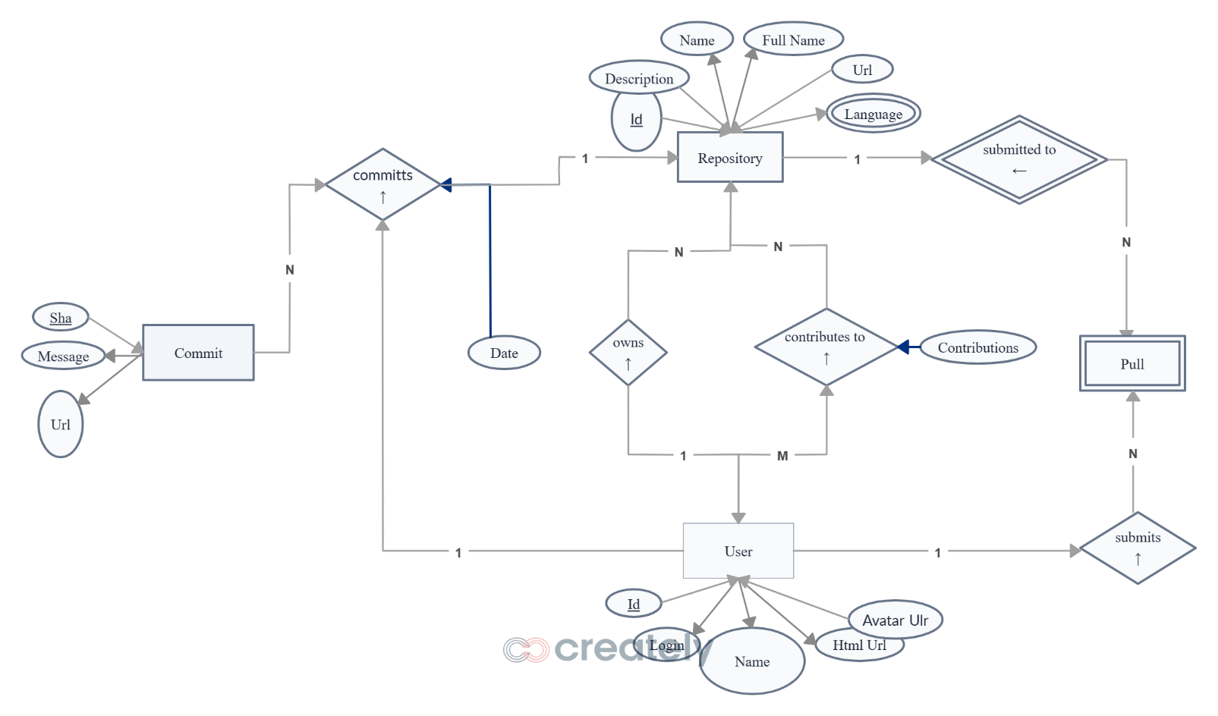

**4.2 Data Flow Diagram (DFD)**

**Purpose:** Shows how data moves through the system at different levels.

**DFD Level 0 (Context Diagram)**

* + - Users interact with the system to create repositories, manage issues, and review pull requests.
    - The system communicates with a **database** to store and retrieve data.

**DFD Level 1**

* + - Users create issues → Issues are categorized → Notifications are sent.
    - Pull requests are created → prioritization → Reviewers are assigned → Code is reviewed and merged.

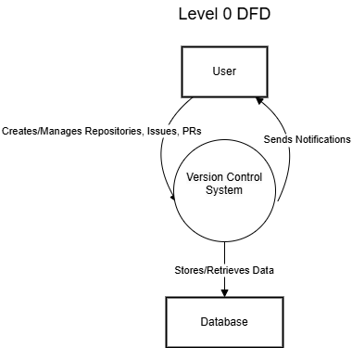

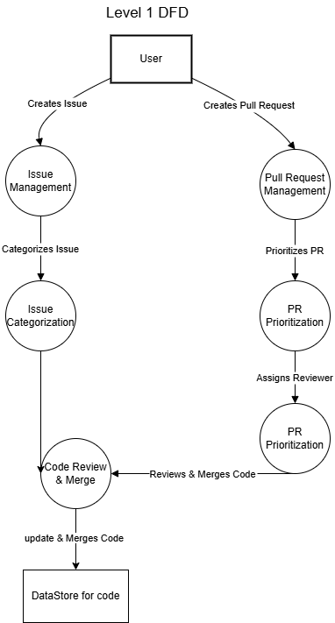

**4.3 Class Diagram**

**Purpose:** Defines the **object-oriented structure** of the system, including classes, attributes, methods, and relationships.

**Key Classes:**

* User (ID, Name, Email, Role)
* Repository (ID, Name, Owner, CreatedAt)
* Issue (ID, Title, Status, AssignedTo)
* PullRequest (ID, Status, AssignedReviewer)
* Review (ID, PRID, Reviewer, Status)

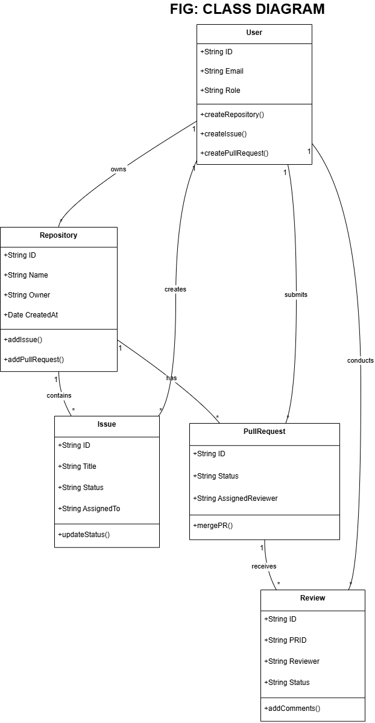

* 1. **Use Case Diagram Purpose**

Illustrates the interaction between users and system functionalities.

**Actors:**

* Developer – Creates repositories, submits issues, pushes code.
* Reviewer – Reviews PRs, approves/rejects changes.
* Admin – Manages users, repositories, and configurations.

**Use Cases:**

* Create Repository
* Create Issue
* Assign Reviewer
* Review Pull Request
* Merge Code

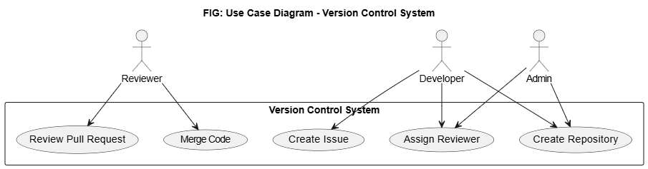

**4.5 Activity Diagram**

**Purpose**: Represents the flow of activities in different system processes.

**Example:** PR Review Process

* Developer submits a pull request.
* AI assigns a priority to the PR.
* Reviewer receives a notification.
* Reviewer reviews code (approve/reject).
* If approved → Merge PR.
* If rejected → Developer modifies code and resubmits.

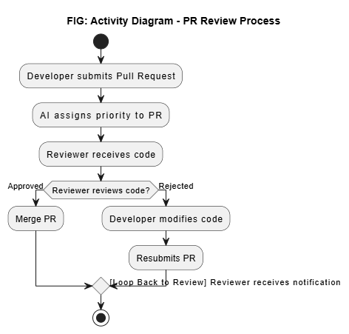

**4.6 Sequence Diagram**

**Purpose:**

The purpose of this sequence diagram is to define the interactions between users and the Version Control System (VCS) for issue tracking. It outlines the process of submitting, managing, and resolving issues in a structured manner. This ensures that developers can efficiently track and resolve software defects while keeping the team informed.

**Example: Issue Tracking in VCS**

* A **developer** submits an issue in the VCS.
* The **system** assigns relevant tags and sets the priority.
* A **notification** is sent to the assigned developer.
* The **developer** fixes the issue and pushes the changes.
* The **VCS** updates the issue status to "Resolved."
* A **notification** is sent to the reporter and team.
* The **developer** closes the issue in the system.

**FIG : SEQUENCE DIAGRAM**

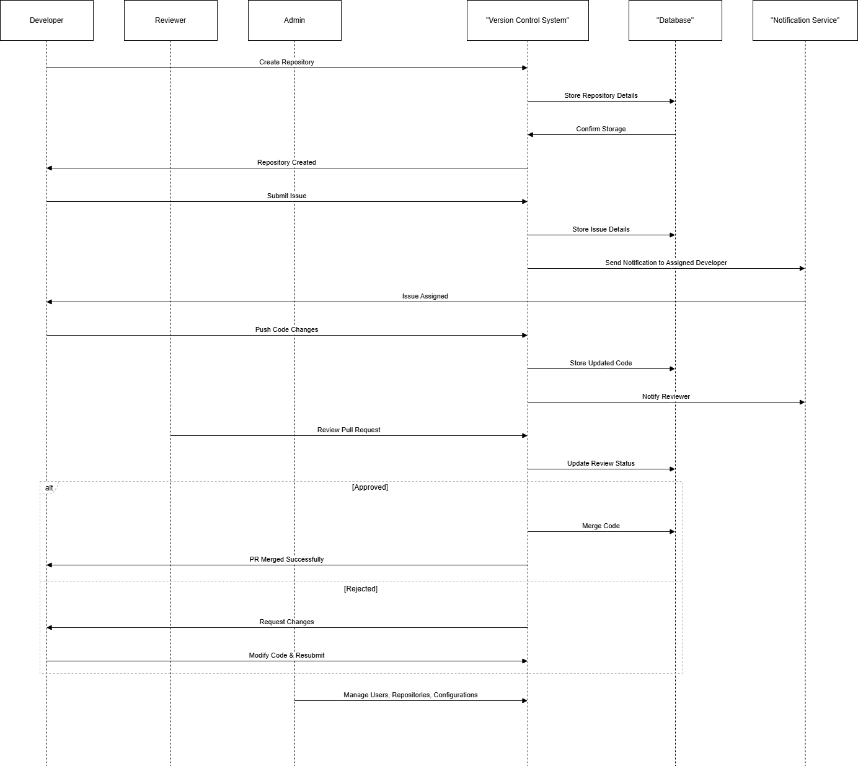

**4.7 Deployment Diagram**

**Purpose:** Defines the **physical architecture** of the system, including servers, databases, and client-side applications.

**Components:**

* **Frontend Server** (React.js) – User interface.
* **Backend Server** (Node.js) – Handles API requests.
* **Database** (MongoDB Atlas) – Stores repository and user data.
* **Cloud Storage** – Stores large files and repositories.

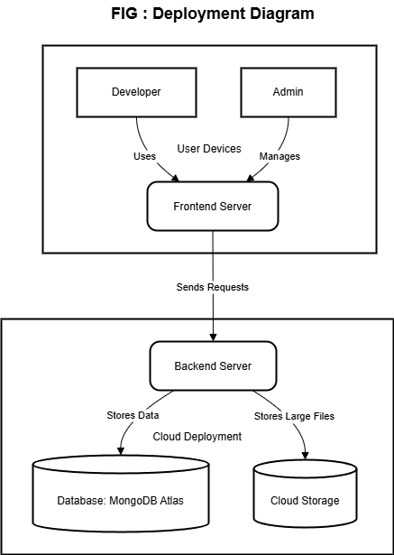

**4.8 Data Dictionary**

**Purpose:** Provides detailed **descriptions of database fields**, including **data types, constraints, and relationships**.

| **Table** | **Field** | **Data Type** | **Description** |
| --- | --- | --- | --- |
| **User** | UserID | String (UUID) | Unique ID of the user |
| **User** | Name | String | Full name of the user |
| **Repository** | RepoID | String (UUID) | Unique ID of the repository |
| **Issue** | IssueID | String | Unique issue identifier |
| **PullRequest** | PRID | String | Unique PR identifier |

# 5. SYSTEM IMPLEMENTATION

**5.1 Overview**

System implementation refers to the process of integrating and deploying the version control system (VCS) into an operational environment. This includes setting up the necessary infrastructure, installing required software components, and ensuring smooth functionality through testing and monitoring.

**5.2 Steps in System Implementation**

The implementation of the VCS follows these key steps:

**1. System Setup and Configuration**

* Install and configure the frontend and backend servers.
* Deploy the database (MongoDB Atlas) and ensure proper connectivity.
* Set up cloud storage for large file handling.

**2. Repository Initialization and Access Control**

* Create a centralized repository for code storage.
* Define access control policies and authentication mechanisms.
* Assign user roles (Developer, Admin, Reviewer).

**3. Integration with Development Workflow**

* Connect the VCS with issue tracking and CI/CD pipelines.
* Automate version control tasks using hooks and scripts.
* Enable real-time notifications for commits, merges, and issues.

**4. Testing and Debugging**

* Perform unit and integration testing for different components.
* Validate system functionality with test cases.
* Fix identified bugs and optimize system performance.

**5. Deployment and Monitoring**

* Deploy the system on a cloud platform (AWS, GCP, or Azure).
* Implement monitoring tools to track system performance and security.
* Conduct user training sessions and documentation for smooth adoption.

**5.3 Expected Outcomes**

* A fully functional and accessible VCS for software development teams.
* Secure and efficient version control with proper access management.
* Seamless collaboration between developers with automated workflows.

# 6. INPUT-OUTPUT SCREEN & REPORTS

# 

# Fig: Register Screen

# 

# Fig: Login Screen

# 

# Fig: Home Screen1

# 

# Fig: Home Screen2

# 

# Fig: Project Directory View

# 

# Fig: Directory Logs and Changes View

# 

# Fig: Code Editor for Pulling code and Pushing code

# 

# Fig: Code Changes Log

# 

# Fig: Code File Tag and Comment Adding

# 

# Fig: Back End Storage Structure

# 

# Fig: Front End Code View

# 

# Fig: Back End Code View

# 7. LIMITATIONS

**Limitations of a Version Control System (VCS) Project**

1. **Lack of Collaboration Mode**

* The system does not support real-time collaboration for multiple developers.
* Merging and managing code changes can be challenging without built-in collaboration features.

1. **No Progress Tracking**

* The system lacks built-in tools to track project milestones and progress.
* Developers may need external tools to monitor version history and workflow status.

1. **Limited User Access Control**

* Without proper role-based access control, unauthorized changes may occur.
* Managing permissions for different contributors can be challenging.

1. **Scalability Issues**

* As the number of users and code repositories grows, performance bottlenecks may arise.
* The system needs an efficient architecture to handle large-scale projects.

1. **Conflict Resolution Challenges**

* Manual conflict resolution can be time-consuming and complex.
* Lack of automated merging strategies may lead to code inconsistencies.

1. **Security Concerns**

* The system must ensure data integrity and prevent unauthorized modifications.
* Encryption and backup mechanisms should be in place to safeguard repositories.

1. **High Infrastructure and Maintenance Costs**

* Hosting and maintaining a VCS requires reliable servers and storage solutions.
* Regular updates and security patches add to operational costs

# FUTURE ENHANCEMENTS

**Future Enhancements for a Version Control System (VCS) Project**

1. **Collaboration Mode**

* Implement real-time collaboration features, enabling multiple developers to work on the same code simultaneously.
* Introduce a pull request and review system to streamline team contributions.

1. **Progress Tracking**

* Integrate a dashboard for tracking project milestones and version history.
* Add analytics and reporting tools to monitor team activity and code changes.

1. **Advanced User Access Control**

* Implement role-based access management to control user permissions.
* Introduce an approval workflow for merging critical code changes.

1. **Scalability Improvements**

* Optimize database and repository storage for handling larger projects efficiently.
* Introduce cloud-based solutions for dynamic scaling and load balancing.

1. **Automated Conflict Resolution**

* Develop intelligent merge conflict resolution tools to minimize manual interventions.
* Implement AI-based suggestions for resolving code conflicts.

1. **Enhanced Security Features**

* Introduce end-to-end encryption for repository data protection.
* Implement multi-factor authentication (MFA) and audit logs for security compliance.

1. **Cost Optimization**

* Optimize resource usage to reduce hosting and maintenance costs.
* Explore open-source alternatives or hybrid cloud solutions for better cost efficiency.

# 9.CONCLUSION

The Version Control System (VCS) project provides a solid foundation for managing code versions, tracking changes, and maintaining a structured development workflow. However, certain limitations, such as the lack of collaboration features, progress tracking, and scalability challenges, impact its overall efficiency.

By implementing future enhancements like real-time collaboration, advanced user access control, automated conflict resolution, and enhanced security measures, the system can evolve into a more robust and scalable solution. Addressing these limitations will not only improve usability but also enhance team productivity and ensure the long-term success of the VCS.

With continuous improvements and optimizations, the project can become a highly reliable and efficient version control system suitable for modern development teams.

# 10.REFERENCES

1. **Chacon, S., & Straub, B. (2014). *Pro Git (2nd Edition)*. Apress.**
2. **Loeliger, J., & McCullough, M. (2012). *Version Control with Git: Powerful Tools and Techniques for Collaborative Software Development (2nd Edition)*. O’Reilly Media.**
3. **Spinellis, D. (2005). *Version Control Systems: Tools for Managing Source Code and Projects*. IEEE Software.**
4. **GitHub Documentation –** [**https://docs.github.com**](https://docs.github.com)
5. **GitLab Documentation –** [**https://docs.gitlab.com**](https://docs.gitlab.com)
6. **Atlassian Bitbucket Documentation https://support.atlassian.com/bitbucket**
7. **Mercurial SCM Guide –** [**https://www.mercurial-scm.org**](https://www.mercurial-scm.org)
8. **Apache Subversion (SVN) Documentation –** [**https://subversion.apache.org**](https://subversion.apache.org)